Continuing Grinnell CS Faculty
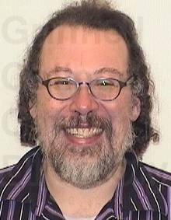  Samuel Rebelsky | 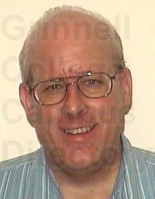  John David Stone | 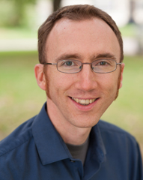  Jerod Weinman

Transitioning CS Faculty
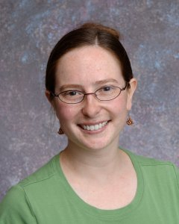  Janet Davis  Moving to Whitman College as Founder of CS Program | 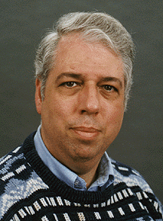  Henry Walker  Sabbatical leave followed by Senior Faculty Status

New CS Faculty
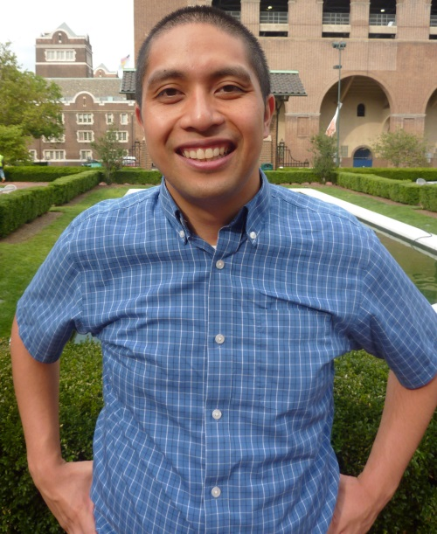  Peter-Michael Osera  Type theory,  Prog. languages,  U. of Pennsylvania | 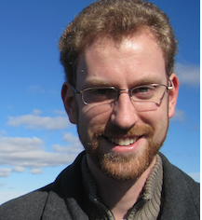  Charlie Curtsinger  Software security, performance,  U. Mass, Amherst | ?????  ​​​?????  ?????  ?????  Noyce Vising Professor

